Person Conducting a Business or Undertaking (PCBU) Details
Business Name: |  |  | Contact Name:
ABN |  |  | Contact Position:
Address: |  |  | Contact Phone:
Project Details:
Project Location: |  |  | Principal Contractor
Job Description:
SWMS Review: This SWMS has been prepared in consultation with Workers.
Prepared By |  |  | Reviewed By:
Prepared On |  |  | Reviewed On:
High Risk Activities
Notes & Comments:
Plant & Equipment Required |  | Hazardous Materials Used
Personnel Qualifications & Training Required |  | Permits Required
Legislation, Codes of Practice, & Standards
Personal Protective Equipment Required
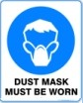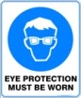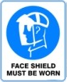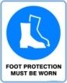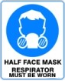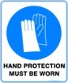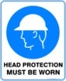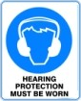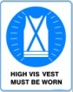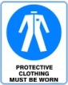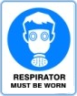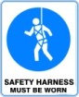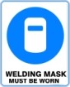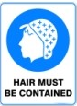
Hierarchy of Controls
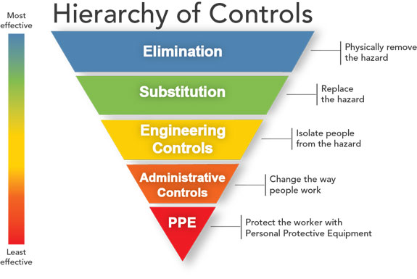Elimination
Physically removing the hazard is the most effective hazard control

Substitution
Substitution involves replacing something that produces a hazard (similar to elimination) with something that does not produce a hazard

Engineering controls
Engineered controls isolate people from hazards. E.g. Guards on machines/tools.

Administrative controls
Administrative controls are changes to the way people work e.g procedures, employee training, and installation of signs and warning labels

Personal protective equipment
PPE is the least effective means of controlling hazards because of the high potential for damage to render PPE ineffective.

Risk Matrix
Risk Level | Description of Consequence or Impact | Consequence | Likelihood/Probability
 |  |  | L  (Likely) | M  (Moderate) | U  (Unlikely)
1 - High  (High level of harm) | Potential Death, Permanent Disability, or Major Structural Damage. Off-site release not contained, major remediation required with outside assistance, significant detrimental environmental impact. | 1 - High | 1 | 1 | 2
2 - Medium  (Medium level of harm) | Potential Temporary, Disability, or Minor Structural Damage. On site release contained, minor remediation required with outside assistance, short-term detrimental environmental impacts. Any potential for exceeding a Statutory Licence Permit condition. | 2 - Medium | 1 | 2 | 3
3 - Low  (Low level of harm) | Potential incident that has the potential to cause persons to require first aid. On-site release immediately contained minor level clean up with no short-term environmental impacts. | 3 - Low | 2 | 3 | 3
Level | Likelihood/Probability
Likely | Could happen frequently
Moderate | Could happen occasionally
Unlikely | May occur only in exceptional circumstances

Task or Activity | Possible Hazard or Risks | Risk Level  Before | Risk Control Measures | Risk  Level  After
Prior to Entering Site
Screening Questions | - Answering Yes to one or more of the screening questions | H | DO NOT ENTER SITE IF:  - You are displaying COVID-19 symptoms.  - You have returned from overseas travel in the last 14 days.  - You have been in contact with anyone diagnosed with COVID-19 in the last 14 days.  - You have been diagnosed with COVID-19.  - You have travelled to mainland China, Iran, Hong Kong, Italy, Republic of Korea, Mongolia (including transit via airports) within the past 14 days?  - You have been in contact with someone who has | L
Screening Questions cont. | - Attending work site with while displaying possible COVID-19 symptoms | H | If you are suffering from any of the following symptoms you will need to seek medical advice and are required to provide a medical clearance indicating you are fit for work:  - Fever  - Coughing  - Sore Throat  - Fatigue  - Shortness of Breath | L
While Working on Site
Social / Physical Distancing | - Contracting COVID-19 through physical contact or close physical proximity  - Spreading COVID-19 through contact or close physical proximity | H | - Maintain a 1.5 meter physical distance between yourself and others  - One person per 4 square meters when working in enclosed or internal spaces  - Avoid physical contact with others  - Stagger break times to avoid crowding  - Essential workers only – Limit external visits to site (e.g. Inspections)  - Third party visits should be contactless when possible (e.g. Deliveries) | L
Worker Hygiene | - Contracting COVID-19 through second hand contact  - Spreading COVID-19 through second hand contact or close physical proximity | H | - Sanitise your hands before entering the site  - Wear gloves while working  - Avoid touching your eyes and face  - Cover mouth and nose when coughing and sneezing (use elbow or tissue)  - Wash hands frequently  - Bin cigarette butts | L
Site Hygiene | - Contracting COVID-19 through physical contact or close physical proximity  - Contracting COVID-19 through second hand contact  - Spreading COVID-19 through second hand contact or close physical proximity | H | - Provide adequate cleaning products and facilities for all workers  - Clean shared tools / plant before and after each use  - Clean shared site amenities frequently and to an industrial standard (lunch rooms, offices, toilets, drink fountains)  - Avoid shared contact of common touch points (e.g. Leave doors open when possible)  - General housekeeping | L
Staying Informed | - Site personnel unaware of most recent government guidelines | H | - New on-site inductions explaining COVID-19 safety measures  - Conducting regular Toolbox Talks for any questions or updates regarding Government COVID-19 updates  - Print off Government educational posters to keep workers educated  - Advise all workers what steps should be taken if they contract the virus or have been in contact with someone with the virus  - Workers should know:  - When to stay away from the workplace  - What action to take if they become unwell  - What symptoms to be concerned about. | L

Sign Off Sheet This SWMS has been developed through consultation and has been read, understood and signed by all employees undertaking the works
Name | Signature | Company | Date

